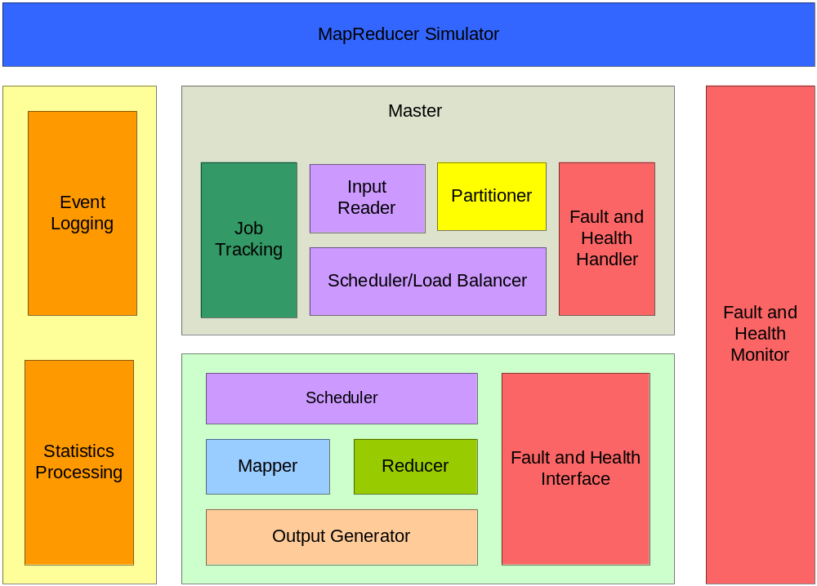

http://en.wikipedia.org/wiki/MapReduce

Some of this was based off of the Wikipedia site

MapReducerSimlator – Entry point into the program. It could read a config file that will drive how the system will run. We could have settings for how many mappers and reducers, when to kill processes, how many to kill at a time, set efficiencies. Basically this block can touch any part to simulate stuff.

Everything else I think is self explanatory. Reference the Wikipedia site.

